Noah McCarthy
Assignment 10.2
Custom Tags
In this paper, I plan to discuss what custom tags are, their advantages and disadvantages, and then finally, details on how custom tags work and how to implement them, and closing with my opinions.
To start off, JSP or Java Server Pages has the option to use custom tags that are user-defined, and they are used to provide a better way to implement code inside of a JSP. As custom tags help reduce Java scriptlets in the JSP. A scriptlet in a JSP is the Java code between these markings “<% %>”, as they allow you to implement Java code into the page.
As for the advantages and disadvantages of Custom tags, lets start with the advantages. With custom tags, they ultimately provide a cleaner coding experience in terms of readability and reusability, as they avoid mixing Java code with your HTML code. In terms of reusability, custom tags can be like a CSS style sheet where the logic can be reused across multiple JSP pages. As for disadvantages, it was a little hard to find information on. So basically, custom tags can add more complexity to the process if done improperly. What is meant by that is that HTML can end up in the Java code and mess up the goal of custom tags in the first place, which is to make it easier for frontend development to be more separated from the back end, but in that scenario, it makes it harder for the frontend to do what might need to be done.
Then, as for the types of Custom tags and how to implement them, let's start with the types. The two types of custom tags are an empty custom tag and a non-empty custom tag. The difference is that the empty custom tag does not contain a body, while the non-empty custom tag contains a body. According to Pandey, S. (n.d.), “To create and use custom tags, you need the following components: Tag Handler, TLD(Tag Library Descriptor), TaglibDirective.” A tag handler is basically a Java class that can implement a tag’s function. Pandey, S. (n.d.) states, “The tag handler class must implement or extend certain interfaces or classes like “SimpleTagSupport” for handling the tag’s lifecycle.” The life cycle of a tag handler is pretty simple. At runtime, it assists the JSP container in creating an object. Once the object is made, it calls the methods on the tag handler, and then the object waits till it is called for use. The JSP will handle all the occurrences of the different tag handlers on the page doing this. With the tag handler comes a few different components, there is a tag interface, IterationTag interface, a TagSupport class, a BodyTag interface, a BodyTagSupport class, a SimpleTag interface, and lastly a SimpleTagSupport class. Then the Tag Library Descriptor is an XML file that can describe the custom tag and route it to the intended Java class. Some key parts of the Tag Library to note are the <taglib>, <tlib-version>, <jsp-version>, <uri>, <tag>, and <attribute>. Some of these are self descriptive, but I will go over the few that aren’t so much. With <taglib>, it is a core part that defines the configuration of the tag library. Then the <uri> tag allows you to provide a unique identifier to access your tag library. Then <tag> will represent a custom tag on the page with <attribute> setting properties for your tag. Lastly, the Taglib Directive directs the JSP to use the tag library using the URI of the tag library along with the prefix. As for how you would implement this, you would first create a TLD file, then your Tag handler, and then just link your Taglib Directive.
In conclusion, let’s talk about my thoughts on custom tags as a whole. I think they are a good way to use to make the process of coding the front-end page a lot cleaner. This way it helps separate the front end from the back end pretty well. However, I can see the case of it going bad with the actual Java being separated in terms where HTML might end up in the Java code. However, I think in those situations it might be better to incorporate Java scripts.

Coding segments from GeeksForGeeks (n.d)
TLD
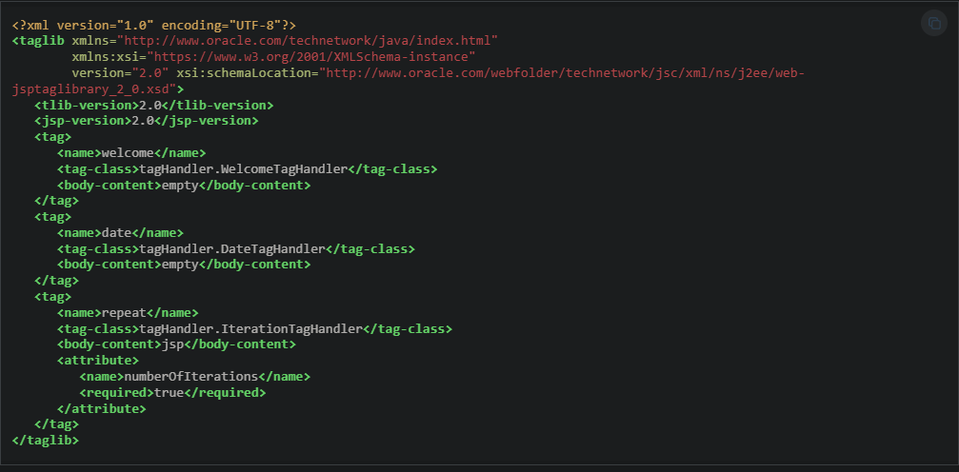
A Welcome tag handler
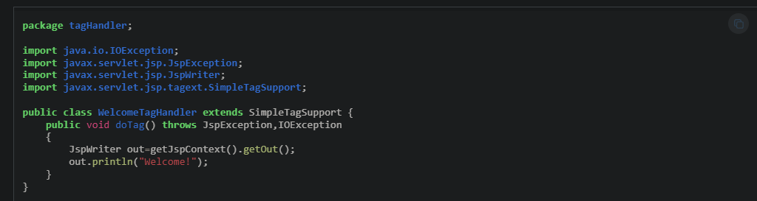
Taglib Directive (uses more handlers than shown)
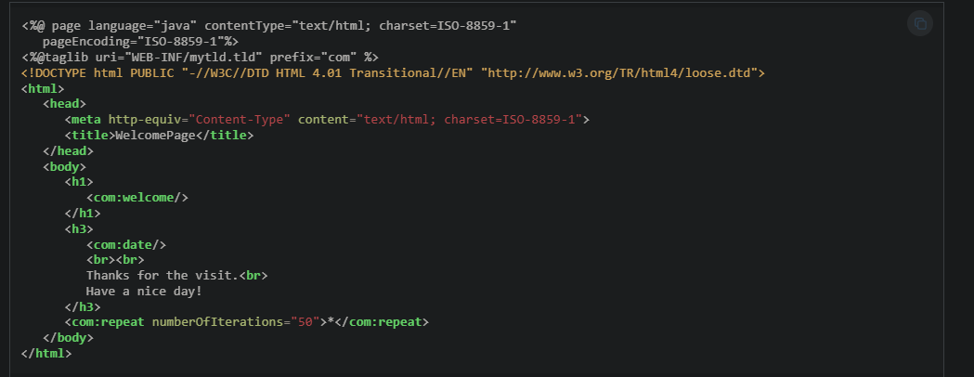
Result
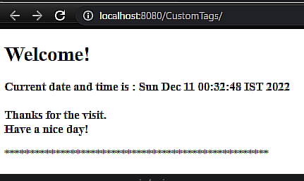

References
Pandey, S. (n.d.). Advanced Java: Custom tags in JSP. Medium. https://medium.com/@SachinPandeyOnline/advanced-java-custom-tags-in-jsp-da3f324e8ee0
GeeksforGeeks. (n.d.). Custom tags in JSP. https://www.geeksforgeeks.org/java/custom-tags-in-jsp/

